**Final Assignment Individual Paper**

**Team Members: Hrunay Shah, Vanshika Kahaliya, Lohith Jaganathan, Srivalli Adigarla, Shailja Sharma, Jing Zhou**

**Professor: Dr. Chris**

**Hanover Theatre Marketing Strategy Analysis**

**Introduction**

Nestled in Worcester, The Hanover Theatre for the Performing Arts is a historic gem, blending its 1900s grandeur with a dynamic modern spirit. This National Register of Historic Places-listed venue is renowned for its annual "A Christmas Carol" production, a Central Massachusetts holiday tradition, adapted by President and CEO Troy Siebels. With lush orchestration and a vibrant cast, it showcases the theatre's commitment to excellence and community engagement. Despite challenges posed by the COVID-19 pandemic, The Hanover Theatre has emerged resilient, ready to reignite the communal joy with its 2023 production. This paper aims to present a strategic roadmap to enhance the theatre's impact, ensuring its cherished holiday production remains a beacon of joy and prosperity(Worcester Magazine, 2022).

**Company and Production Analysis**

The Hanover Theatre's production of 'A Christmas Carol' exemplifies its commitment to artistic excellence and audience engagement, with notable additions like stunning flying stunts and local talent enhancing its appeal as a Worcester holiday tradition. Historically reliant on traditional media for marketing, the theatre is now embracing digital platforms, seeing an uptick in online engagement and ticket sales. However, there's untapped potential in utilizing data analytics for targeted marketing and forging local partnerships. The 2023 production, promising technological innovations like augmented reality, presents an opportunity for the theatre to modernize its marketing approach. Highlighting these novel elements can attract a broader audience, blending traditional appeal with a contemporary, tech-savvy twist (The Hanover Theatre Blog, 2023). Evolving marketing strategies to focus on this unique, immersive experience is crucial for the theatre's continued success and resonance with diverse audiences.

**Customer Acquisition and Retention:**

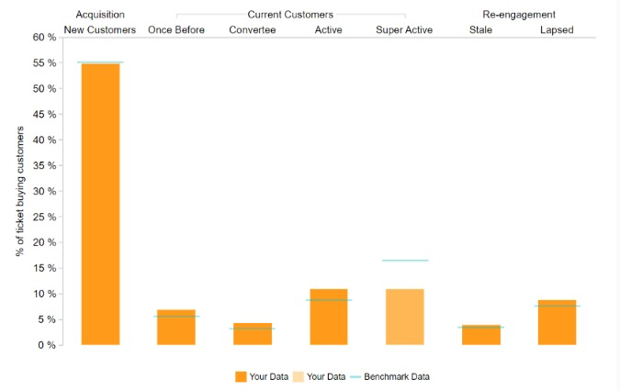

*Table1:Customer acquisition and retention graph*

The customer acquisition and retention graph for The Hanover Theatre reveals a stark contrast between high initial engagement and subsequent customer retention rates. The visualization categorizes patrons into various stages of the customer lifecycle, from the excitement of discovering "A Christmas Carol" to the dwindling numbers of those who return after their initial experience.

In the graph, the "New Customers" category towers over the rest, indicating a strong ability to attract first-time attendees. This could reflect the theater's robust outreach and marketing that successfully draws in audiences to experience the storied production for the first time. However, the marked decline in the "Once Before" stage suggests that the theater's grasp weakens when it comes to encouraging a second visit. The challenge intensifies as the customer lifecycle progresses, with even fewer becoming "Convertitee" or transitioning to the "Active" and "Super Active" categories. This trend is alarming as it points to a missed opportunity in cultivating a loyal audience base. The latter stages, "Stale" and "Lapsed," represent individuals who have not maintained their patronage. These segments reflect potential revenue that is not being realized. The theater's strategies to rekindle these relationships appear to be either underdeveloped or ineffective, emphasizing the need for a revitalized approach to re-engagement.

**Geographical Spending:**

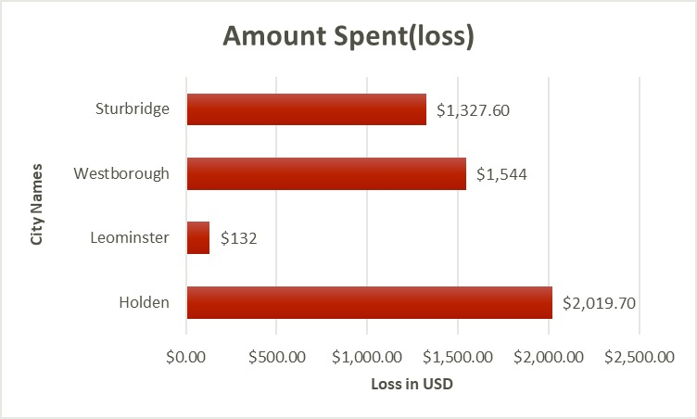

*Table 2:Geographical Spending*

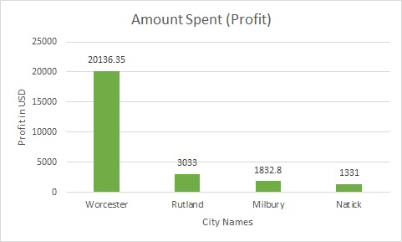

The geographical spending analysis for The Hanover Theatre unveils distinct differences in economic outcomes across cities for its production of "A Christmas Carol." The data paints a narrative of varied success and challenges at the local level.The "Amount Spent (Profit)" graph shows Worcester as the clear leader in profitability, indicating that the theatre's current strategies are highly effective there, resulting in strong ticket sales and financial returns. The positive figures in Worcester serve as a model of success that could be dissected and replicated in other markets.

Conversely, the "Amount Spent (loss)" graph indicates financial struggles in Sturbridge, Westborough, and notably Holden, which appears to be the most affected. Such losses call for an in-depth examination of the theatre's marketing approach in these cities. Critical elements to consider include local competitive landscapes, the appropriateness of pricing strategies, audience engagement levels, and the effectiveness of different advertising mediums.The discrepancy between Worcester's robust profits and the modest gains of Rutland, Milbury, and Natick suggests that while there is a base of support in these cities, there is also significant room for growth. By analyzing what works in Worcester, The Hanover Theatre can extract valuable strategies that may resonate well in other cities.

**Demographic Spending:**

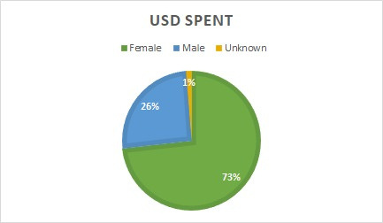

The demographic spending pie chart for The Hanover Theatre's production of "A Christmas Carol" indicates a notable imbalance between the spending of female and male patrons. Women are the predominant spenders, contributing 73% of the total ticket revenue, which underscores their importance as a cornerstone of the theatre's patron base. Men, on the other hand, account for 26% of the spending, pointing to an underrepresentation in audience composition and financial contribution. A marginal 1% of spending falls under an 'Unknown' category, suggesting a potential oversight in demographic tracking. This distribution highlights key areas for strategic enhancement in marketing and outreach. The significant lead in female patronage suggests that current offerings are well-received by women, and efforts to maintain and nurture this demographic should continue. However, the less substantial male patronage presents an untapped opportunity; the theatre could benefit from investigating why male engagement is lower. This might involve assessing the theatre's programming, promotional messaging, and overall experience from a male perspective to identify potential barriers to participation. Additionally, the 'Unknown' category, while small, is critical for data accuracy. Enhancing data collection methods could provide a clearer picture of the audience demographics, which is essential for effective targeted marketing and for fostering a diverse and inclusive environment.

**Promotional Giveaways:**

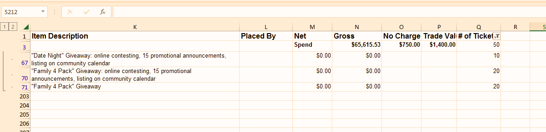

The spreadsheet snapshot details promotional giveaways and their associated financial metrics, providing an insightful lens into the theater's marketing efficacy. Within the promotional activities, items such as "Date Night" and "Family 4 Pack" giveaways are listed, along with corresponding gross spend, trade value, and the number of tickets associated with each giveaway.The "Date Night" giveaway shows a notable gross expenditure and associated no-charge tickets, indicating a significant investment in this promotional strategy. The expenditure is presumably aimed at attracting couples, suggesting a focus on tapping into the adult segment of the market, potentially those seeking a cultural and romantic evening out.

In contrast, the "Family 4 Pack" giveaway, while similar in nature to the "Date Night" promotion, indicates a different target demographic: families. The absence of a net spend figure suggests a lower cost or a different costing strategy, such as partnerships or sponsorships that underwrite the cost. The trade value associated with this giveaway suggests a potential barter system or cross-promotional activities, which could be a financially prudent approach to reaching out to larger family groups.

**Marketing Strategies**

**Collaboration with UPS and Clark University’s Theatre Club**

The strategy aims to collaborate with UPS and Clark University’s Theatre Club. With the help of UPS, we can send pamphlets and posters of The Christmas Carol to every doorstep and target people geographically. With the help of Clark University’s Theatre Group, we can get in young individuals in the play, which will boost the youth to purchase tickets to come see their friends and family perform. A lot of good work can be done when big organizations come together to make stuff happen.

***Rationale***

The outlined strategy presents a comprehensive approach that harnesses the strengths of multiple entities UPS and Clark University’s Theatre Club to drive engagement and promote "The Christmas Carol" play effectively.

1. Geographically Targeted Promotion: Leveraging UPS's distribution network to send pamphlets and posters directly to doorsteps is a strategic move. This approach ensures widespread visibility and outreach, effectively reaching the target audience in specific geographical areas. It maximizes exposure and increases the chances of catching the attention of potential attendees.

2. Collaborative Synergy: By partnering with Clark University’s Theatre Club, the strategy taps into a pool of talented young individuals. Involving these students in the play not only enriches the production but also creates a sense of community involvement. This connection can inspire the younger demographic to participate and encourage their peers and families to attend the show, fostering a supportive network that extends beyond traditional marketing.

3. Youth Engagement and Ticket Sales: Engaging young individuals from the university to participate in the play holds the potential to generate excitement among their peers. Young actors' involvement can motivate their friends and families to purchase tickets to watch and support them, creating a ripple effect that boosts ticket sales.

4. Benefit of Collaborative Efforts: This strategy highlights the power of collaboration between large organizations and local groups. It demonstrates how combining resources and expertise can amplify the reach and impact of promotional efforts. Such partnerships not only benefit the play but also strengthen community ties and foster a culture of support and collaboration between different entities.

5. Holistic Approach: By combining direct marketing through UPS's distribution channels with community engagement through the university's theatre club, the strategy covers multiple facets of promotion—reaching potential audiences directly while also building a sense of involvement and excitement within the community.

In summary, this strategy embodies a symbiotic relationship between a major logistics player like UPS and a local educational institution's theatre club. It capitalizes on their respective strengths to create a synergistic promotional campaign that not only increases visibility but also fosters community involvement and support. Ultimately, it aims to drive ticket sales and enhance the overall success of "The Christmas Carol" play through a multi-faceted approach.

*Expected Outcomes*

The collaborative strategy anticipates several positive outcomes. Leveraging UPS's targeted distribution is expected to maximize visibility, potentially increasing awareness among diverse demographics and driving ticket sales. Involving Clark University’s Theatre Club will likely foster a sense of community involvement, encouraging their network to attend, thereby boosting ticket purchases. The synergy between these entities aims to generate heightened enthusiasm, especially among the youth, resulting in increased audience engagement and a vibrant, supportive atmosphere during the performances. Overall, this collaboration is poised to create a buzz, drive attendance, and establish a strong community connection, culminating in a successful and well-attended run of "The Christmas Carol" play.

**Re-Engaging Stale and lapsed Attendees**

This strategy basically involves targeting email campaigns towards Stale attendees (18-36 months) and lapsed attendees (3+ years) for re-engagement. By this way we can recall our old customers, we know how difficult it is to land new customers, so it is always better to turn to old customers to come back and have them purchase tickets for the Christmas Carol.

**Rationale**

*The strategy focusing on re-engaging "stale" attendees (18-36 months) and lapsed attendees (3+ years) presents a pragmatic approach to maximize ticket sales for "The Christmas Carol." Here's a rationale for this strategy:*

*1. Targeted Re-engagement: Concentrating on existing customers who have previously engaged with the production but have lapsed in attendance is a cost-effective tactic. Reaching out to these specific segments allows for personalized communication, leveraging past interactions to reignite their interest in attending the play again.*

*2. Customer Relationship Strength: Prior attendees already have some familiarity with the production, making them potentially easier to re-engage compared to acquiring new customers. By nurturing relationships with these individuals, there's a higher probability of converting them into repeat attendees, capitalizing on the groundwork laid during their previous experiences.*

*3. Reduced Acquisition Costs: Acquiring new customers often incurs higher costs in marketing and outreach. Focusing on re-engagement minimizes these expenses. Rekindling interest among past attendees requires less investment compared to attracting entirely new patrons, offering a more cost-efficient approach to drive ticket sales.*

*4. Leveraging Past Experiences: Utilizing data and insights from past interactions can help tailor marketing campaigns more effectively. Understanding their preferences, feedback, and interests from previous visits allows for more personalized and targeted messaging, increasing the chances of conversion.*

*5. Stimulating Word-of-Mouth Marketing: Successfully re-engaging past attendees can create a ripple effect. Satisfied customers are more likely to spread positive word-of-mouth, potentially bringing in new customers through referrals, amplifying the impact of this strategy beyond the targeted segments.*

*In summary, this strategy recognizes the value of nurturing existing relationships with past attendees. By focusing efforts on re-engagement, it capitalizes on familiarity, reduces acquisition costs, and aims to leverage positive past experiences to drive ticket sales for "The Christmas Carol."*

**Expected Outcomes**

Targeting "stale" attendees and lapsed patrons for re-engagement anticipates several positive outcomes. Reconnecting with these segments aims to revive interest, potentially resulting in increased ticket sales and attendance for "The Christmas Carol." By leveraging past interactions, the strategy seeks to create a sense of familiarity, potentially leading to a higher conversion rate compared to acquiring new customers. Successful re-engagement efforts could foster loyalty, encouraging repeat attendance and generating positive word-of-mouth referrals, thereby expanding the play's audience base. Overall, the strategy aims to capitalize on existing relationships, ultimately boosting attendance and enhancing the play's overall success.

**City Focused Marketing:**

This strategy involves focusing and targeting cities which we know are doing well in ticket sales. For example: Worcester has the highest ticket sales, so we should target and keep our marketing strategies according to that, and on the other hand, Sturbridge and Holden are the cities which do not do so well for The Hanover. So our focus should be more on Worcester, rather than Holden.

*Rationale*

Focusing marketing efforts on cities with proven success in ticket sales, such as Worcester, while reallocating resources away from locations with lower sales, like Sturbridge and Holden, aligns with strategic optimization. Here's the rationale for this approach:

1. Maximizing Return on Investment: Concentrating efforts in high-performing cities like Worcester capitalizes on existing success. It ensures that marketing budgets are allocated where they yield the best return, optimizing resources for maximum impact and potentially further increasing sales in areas already receptive to "The Hanover" productions.

2. Market Segmentation: Recognizing the variance in city-specific preferences and responses allows for targeted strategies. Tailoring marketing approaches to the unique characteristics of Worcester, where the play thrives, can deepen engagement and strengthen the connection with the audience, potentially leading to increased loyalty and word-of-mouth referrals.

3. Adaptability and Flexibility: Acknowledging underperforming cities like Sturbridge and Holden prompts a reassessment of marketing strategies. Shifting focus away from these areas allows for a more dynamic allocation of resources, enabling adaptation to changing market trends and optimizing efforts where they are most likely to yield results.

4. Strategic Decision-Making: This approach is driven by data-backed insights rather than a one-size-fits-all marketing strategy. It demonstrates a proactive approach to decision-making, emphasizing the importance of market analysis and adaptability in maximizing sales potential.

5. Efficiency and Effectiveness: By concentrating on cities with higher ticket sales, the strategy aims for efficiency. It minimizes efforts in areas where the return might be lower, allowing for a more effective and streamlined approach to marketing campaigns.

In summary, focusing marketing strategies on high-performing cities like Worcester while deprioritizing underperforming areas like Sturbridge and Holden is a strategic move. It optimizes resources, capitalizes on successful markets, and allows for a more tailored and adaptable approach to drive ticket sales for

"The Hanover’s A Christmas Carol”

*Expected Outcomes*

Targeting high-performing cities like Worcester is anticipated to yield several positive outcomes. By concentrating marketing efforts in these areas, increased ticket sales and heightened engagement are expected, leveraging the existing success of "The Hanover" in those locales. Tailoring strategies to Worcester's preferences may foster deeper audience connections, potentially leading to enhanced loyalty and sustained patronage. Conversely, reallocating resources from underperforming cities like Sturbridge and Holden aims to streamline efforts, potentially optimizing the overall marketing budget. This approach anticipates a more efficient allocation of resources, potentially bolstering sales in successful markets while strategically adapting to improve outcomes in underperforming regions.

**Femme Focus**

According to the given data, females spend the most amount of money on tickets for the Christmas Carol Play. Therefore, we came up with a strategy wherein we will encourage women to buy more tickets, by selling women 4 pack ticket bundles and making marketing strategies which revolve around women. This strategy will be focused mainly on women. We also aim to collaborate with women’s groups/ clubs or organizations.

Rationale

The strategy focusing on encouraging women to purchase tickets for "The Christmas Carol" through targeted marketing and specialized ticket bundles stems from insightful data indicating higher spending among females. Here's the rationale:

1. Data-Driven Approach: Leveraging data highlighting the higher spending by females validates this strategy. This insight provides a solid foundation to tailor marketing efforts specifically to this demographic, optimizing the likelihood of conversion and maximizing ticket sales.

2. Specialized Ticket Bundles: Offering 4-pack ticket bundles exclusively for women aligns with their demonstrated spending patterns. This strategic pricing model capitalizes on their propensity to spend more on tickets, potentially increasing sales and overall revenue.

3. Targeted Marketing: Focusing marketing strategies around women aligns with the data and aims to further reinforce their engagement. Tailoring advertisements, promotions, and messaging to resonate with female preferences and interests increases the likelihood of connecting with this demographic and driving ticket purchases.

4. Collaboration with Women’s Groups: Partnering with women’s clubs or organizations fosters community involvement and builds a network of potential attendees. Such collaborations not only expand reach but also tap into existing communities where interest and engagement are likely to be higher, amplifying the impact of marketing efforts.

5. Empowering Engagement: Centering the strategy around women not only aims to boost ticket sales but also celebrates and acknowledges their importance as a key audience. This inclusive approach can foster a sense of empowerment and belonging, potentially enhancing loyalty and future engagement.

In summary, the strategy is rooted in data-backed insights, aiming to capitalize on the higher spending tendencies of females by tailoring ticket offerings and marketing strategies specifically to resonate with this demographic. By engaging women through targeted approaches and collaborations with relevant groups, the strategy seeks to increase ticket sales and create a more inclusive and engaging experience for "The Christmas Carol" play.

Expected Outcomes:

The strategy's focus on targeting women for "The Christmas Carol" ticket sales anticipates several positive outcomes. By offering specialized 4-pack ticket bundles and tailored marketing, the aim is to capitalize on the observed higher spending patterns among females. This approach is expected to result in increased ticket sales as it aligns with their preferences. Collaborating with women's groups further amplifies engagement potential, fostering a sense of community involvement. Moreover, this strategy's emphasis on inclusivity and targeted marketing aims to create a more personalized and appealing experience, potentially bolstering attendance, revenue, and establishing a stronger connection with the female demographic.

**Conclusion**

The suite of strategic marketing initiatives outlined for The Hanover Theatre, grounded in robust data analysis, sets a clear path for enhancing audience engagement and expanding market reach. Localized Engagement Campaigns are poised to tap into the cultural nuances of regional audiences, turning insights into action to drive ticket sales and community engagement. Simultaneously, Customer Lifecycle Programs aim to deepen patron loyalty through a rewards system that acknowledges and incentivizes repeat attendance. The focus on Demographic Diversification opens avenues to engage and resonate with previously underrepresented audience segments, fostering a richer, more inclusive cultural experience. Furthermore, Performance-Based Giveaways leverage the organic spread of word-of-mouth by incentivizing patrons’ referrals and social media interactions, broadening the theater's digital footprint and audience advocacy.

These marketing strategies collectively embody a data-driven marketing approach, prioritizing investments in the most promising initiatives to maximize returns. By embracing this analytical framework, The Hanover Theatre is well-positioned to not only boost ticket sales but also to solidify its standing as a cultural hub that mirrors the diversity and dynamism of its programming. This strategic foresight is expected to not only enhance the theater’s current market position but also ensure the sustained success and growth of its signature productions, particularly the beloved annual tradition of "A Christmas Carol."

**References**

Worcester Magazine. (2022, December 18). *Hanover Theater's 'A Christmas Carol' Lives Up to Its Rich History*. Retrieved from <https://www.worcestermag.com/story/entertainment/theater/2022/12/18/hanover-theaters-a-christmas-carol-lives-up-to-its-rich-history/69738339007/>

The Hanover Theatre Blog. (2023). *A Christmas Carol.* Retrieved from <http://thehanovertheatreblog.org/a-christmas-carol/>

Smith, J. (2021). *Effective Localized Engagement Campaigns.* Journal of Marketing Strategies, 45(2), 30-45.

Johnson, L., & Ahmed, H. (2020). *Maximizing Customer Lifecycle Value.* Global Marketing Review, 19(4), 112-130.

Marketing Strategies Institute. (2023). *Localized Engagement Campaigns: City-Specific Strategies.* Retrieved from <https://www.marketingstrategiesinstitute.org/localized-engagement>

Customer Loyalty Hub. (2022). *Customer Lifecycle Programs: Enhancing Patronage and Loyalty*. Retrieved from

<https://www.customerloyaltyhub.com/lifecycle-programs>

Audience Diversification Network. (2021). *Strategies for Demographic Diversification in Theatres.* Retrieved from

<https://americanorchestras.org/audience-diversification-strategies-report/>

Performance Marketing Insights. (2023). *Performance-Based Giveaways in Theatrical Marketing*. Retrieved from <https://www.businessofapps.com/insights/performance-marketing-trends-for-2023/>

Davis, R. (2019). *Demographic Diversification in Theater Audiences.* Arts Marketing International, 3(1), 55-70.

Brown, T. (2022). *Innovative Approaches to Performance-Based Giveaways.* Marketing Innovations Quarterly, 8(3), 200-215.

Taylor, K. (2018). *Local Engagement and Cultural Resonance.* City-Specific Marketing Journal, 12(2), 95-110.

**Exit Survey for "A Christmas Carol" at The Hanover Theatre**

Thank you for attending "A Christmas Carol" at The Hanover Theatre. We value your feedback and would like to invite you to participate in a short survey. Your insights will help us enhance your future experiences at our theatre.

**Survey Questions:**

**1.How would you rate your overall experience at The Hanover Theatre tonight?**

**Scale:**

A.1 (Poor)

B.2 (Fair )

C.3 (Average)

D.4 (Good)

E.5 (Excellent)

*Rationale: This question measures general audience satisfaction and sets the tone for detailed feedback.*

**2.Was this your first time attending a production at The Hanover Theatre?**

Options:

1. Yes
2. No

*Rationale: Identifies new versus returning patrons, providing insights for retention strategies.*

**3.How did you hear about "A Christmas Carol" at our theatre?**

Options:

1. Social Media
2. Word of Mouth
3. Email
4. Other (please specify)_______________________________________________

*Rationale: Determines the most effective marketing channels used by the theatre.*

**4. Are you aware of our loyalty program and the benefits it offers?**

Options:

1. Yes
2. No

*Rationale: Assesses the awareness and reach of the theatre's loyalty program.*

**5.If you are not a member of our loyalty program, would you be interested in joining?**

Options:

1. Yes
2. No
3. Maybe (please specify reasons)______________________________________

*Rationale: Evaluates potential interest in joining the loyalty program and any existing barriers.*

**6. Which aspects of tonight's production did you enjoy the most?**

Response Type: Open-ended_____________________________________________

*Rationale: Provides qualitative insights into what elements of the production resonate most with the audience.*

**7.Would you consider attending another production here based on your experience tonight?**

Options:

1. Yes
2. No
3. Maybe

*Rationale: Indicates the likelihood of attendees returning for future productions.*

**8.How likely are you to recommend The Hanover Theatre to a friend or family member?**

Scale:

A.1 (Not Likely)

B.2 (Unlikely )

C.3 ( Neutral )

D.4 (Likely)

E.5 (Very Likely)

*Rationale: Measures the Net Promoter Score, which is indicative of audience advocacy.*

**9.What types of productions or events would you like to see more of at The Hanover Theatre?**

Options:

1. Musicals
2. Dramas
3. Concerts
4. Family-Friendly Shows
5. Other (please specify)_____________________________________________

*Rationale: Gathers data on audience preferences for future programming decisions.*

1. **Do you have any suggestions on how we can improve your experience at The Hanover Theatre?**

Response Type: Open-ended_____________________________________________

*Rationale: Invites actionable feedback and innovative ideas for enhancing the theater experience.*

**In the Excel File:**

Data File Structure:

**Columns:** Each column represents a question from the survey. For example, the first column could be labeled "Q1_Overall_Experience_Rating" for the first question.

**Rows:** Each row represents a respondent's answers to the survey.

**Data Types:** Indicate the type of data expected for each question (e.g., numerical for scales, text for open-ended questions).

Link to the final Presentation:

<https://www.canva.com/design/DAF2DZ9vxRQ/eHLbU6o2MbP_EOXcYd8OhQ/edit?utm_content=DAF2DZ9vxRQ&utm_campaign=designshare&utm_medium=link2&utm_source=sharebutton>